Western Physical Assessment Proficiencies

- Non-verbal vs. verbal interview skills
- Parts of a complete medical history Parts of a Complete Medical History
CC – Chief Complaint
HPI – History of Present Illness
PMI – Past Medical History
FH = Family History
Psychosocial History
ROS – Review of Systems (and Vitals)
- What is a thorough PMI?
- What are the CAGE questions?
C – Ever thought of cutting down drinking?
A – Ever annoyed over others criticism of drinking?
G – Ever felt guilty about drinking?
E – Ever had an “eye opener” drink first thing in the morning to get over the hangover?
- Normal temperature ranges
- Locations of pulses
- Apical pulse
- Normal respiratory rate range
- Taking blood pressure
- Skin differences infants vs. adolescents
Infants
Subcutaneous fat poorly developed
Skin smoother, less oily than adults
Eccrine glands function after 1 month
Apocrine glands do not function
Adolescents
Apocrine glands activated
Increased sebum production
Grow pubic and axillary hair
Facial hair in boys
- Skin changes in pregnancy
Increased blood flow to skin , Increased sweat from sebaceous gland activity, Fat deposits, Stretch marks, Vascular spiders. Increased pigmentation
- What is asked in a skin history assessment?
- DD of skin cancer vs. normal mole with ABCDE
- Assessing skin tugor
To determine turgor, pinch a fold of skin under the clavicle or on the forearm so the top skin separates from the underlying structure.
- Appearance of normal nails vs. abnormal nails
- Head inspection
Hair distribution and quantity
Scalp – scaling, nevi
Skull – size, contour
Face – expression, contours
Skin – color, pigmentation, hair distribution, lesions
- Head and neck lymph nodes
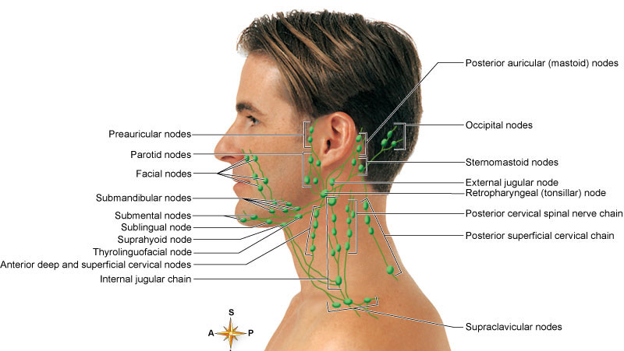
- Test for trigeminal neuralgia and Bell’s Palsy (muscles of mastication)
- Weber’s Test vs. Rinne Test
- General otoscope use
- Eye inspection
General appearance, Conjunctiva, Lacrimal gland, Sclera, Orbital area, Eyelids, lashes, brows, Conjunctivae and sclera, Movement of eyes, strasbismus, nystagmus, Corneal clarity (shine light directly at persons eyes; should see equal reflection) , Iris – colored part , Pupils (round,regular,equal, 3-5mm) Pupillary light reflex- darken room, focus on distant object, shine light from the side results in direct light reflex and consensual light reflex
- Visual acuity
- Nose exam
- Sinus exam
- Transillumination
- Oral cavity exam
- Thyroid exam
- Point out anterior and posterior thoracic landmarks
- Point out thoracic reference lines
Anterior Chest (Midsternal line, Midclavicular line)
Posterior Chest (Vertebral line – Midspinal, Scapular line)
Lateral Chest (Anterior Axillary line, Posterior Axillary line, Mid–axillary)
- Where are lung borders?
- What are major parts of thoracic/chest exam?
- Demonstrate tactile fremitus
Tactile Fremitus – palpable vibration of sound from the larynx (use palmer base of fingers, “99” or Blue Moon)
- Demonstrate lung percussion and diaphragmatic expansion
- Demonstrate lung auscultation
- Lung rates (eupnea, tachypnea, bradypnea)
- Questions to ask before breast exam
History of breast masses and what was done about them
Pain or tenderness in the breasts and relation to the menstrual cycle
Discharge from the nipple
Inquire if the client performs breast self-examination
Estrogen replacement therapy
- Breast inspection
- Breast palpation
- Protocol for high risk breast patients
For client’s who have a past history of breast masses, who are at high risk for breast cancer, examination in both a Supine and a Setting position is recommended
For palpation choose one of three patterns:
Concentric circles
Hands-of-the-clock or spokes-on-a-wheel
Vertical strips

- Axillary exam
- Parts of Cardiac Exam
Inspection, Palpation, Percussion, Auscultation
- Names and locations of anterior chest surface landmarks
- What would you inspect for a cardiac exam?
- What exam findings present with arterial insufficiency
4 P’s of blocked arteries
Pulseless
Pallor
Pain
Paralysis
- Homan’s sign - Thrombophlebitis (Homan’s Sign – calf pain with dorsiflexion)
- PMI
- Describe palpation edema scale
- Bounding pulse vs. pulsus alternans vs. bigeminal pulse vs. pulsus paradoxis
Bounding pulse
A pulse that feels full and spring like on palpation as a result of an increased thrust of cardiac contraction or an increased volume of circulating blood within the elastic structures of the vascular system
Pulsus alternans
Alternating beats are so weak as to be undetected, causing apparent halving of the pulse rate
Bigeminal pulse
Two beats occur in rapid succession, the groups of two being separated by a longer interval
Pulsus Paradoxus
Strong on expiration, weak on inspiration
Present if difference in systolic pressure varies > 15 mm Hg between inspiration and expiration
- Cardiac auscultation
- Location of pulses
- Pulse grading
3 + Bounding
2 + Brisk, expected, normal
1 + Diminished, weaker than expected
0 Absent, unable to palpate

- Edema grading
- Allen test
- Capillary refill test
- Abdominal regions
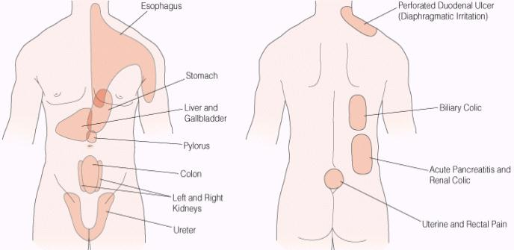
- Examples of referred pain

- Parts of abdominal examination
LOOK - INSPECTION
LISTEN - AUSCULTATION
PERCUSS
PALPATE
- Auscultation bowel sounds
Place the diaphragm over the abdomen to hear bowel sounds (borborygmi) which are long gurgles.
These sounds are transmitted across the abdomen so it is not necessary to listen at several places.
The normal frequency of sound is 5-34 sounds per minute.
- Abdominal percussion
- Liver and spleen palpation
- Abdominal palpation
- Signs for peritoneal inflammation
- McBurney’s point
- Aortic palpation
- Demonstrate fluid wave
- Location of different hernias
- Tanner scale
- Calculate EDC – estimated date of confinement
- Indications for digital rectal exam
- Describe orthopedic history
- Demonstrate upper and lower extremity muscle strength
- Joint bulging vs. joint ballottment
- Cervical orthopedic exam
- Cervical testing for vertebral artery compression vs. nerve root compression vs. disc
- TMJ exam
- Shoulder range of motion testing
- Rotator cuff testing
- Elbow exam
- Varus vs. valgus stress testing
- Tennis elbow vs. golf elbow tests
- Tests for carpal tunnel
- Major parts of neurological exam
- Assess mental status
- What is altered mental status?
- What is altered level of consciousness?
- AEIOU TIPS that may affect mental status
- Cranial nerve examination
- Test upper and lower extremity muscle strength
- Demonstrate DTR
- Demonstrate cutaneous reflexes
- Demonstrate sensory nerve testing
- Dermatone vs.myotone testing
- What to look for in gaits
- Demonstrate two point discrimination
- Demonstrate stereogenesis
Stereogenesis – place a key or familiar object in patient’s hand and ask patient to identify
- How to test for proprioception
Test proprioception – hold big toe by its sides between your thumb and index finger, pull it away from other toes, and move it up and down. Ask patient to identify the direction of movement.
- Rhomberg test (Patient stands with feet together and arms forward, eyes closed, for 30-60 seconds without support. Loss of balance with eyed closed is +)
- How to test for pain

